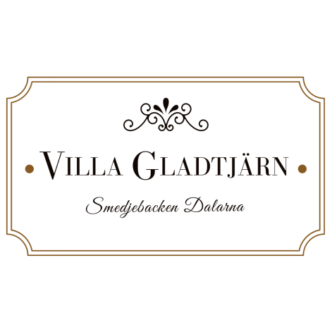
Request For Quote (Events):
Kindly complete and email back to info@villagladtjarn.se
I need to host an event for ___ number of people (Max 400).
I need to host the event from _______ (date) to ______ (date)
I need the venue/s from _______ (time) to _____ (time)
I need catering for ___ number of people (max 400)
I need Audio Visual Equipment (Yes | No)

Signed : ______________

Date of Request: ________

